EMPLOYEE

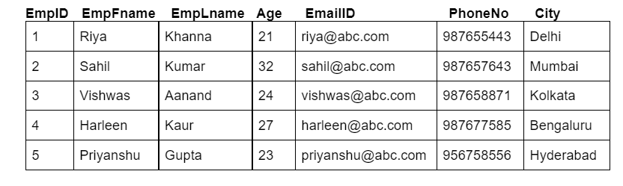

PROJECT

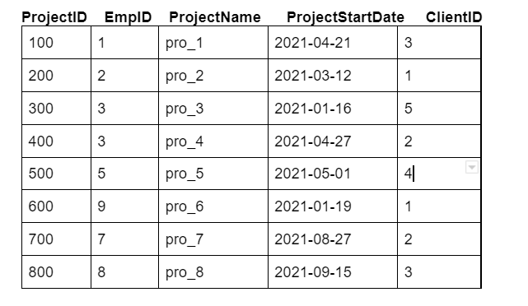

CLIENT_D

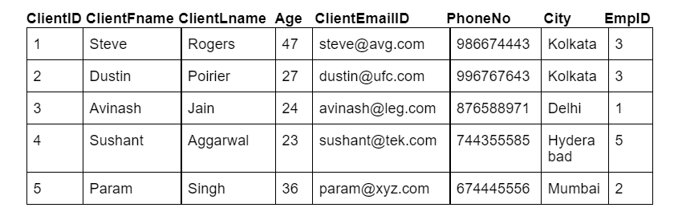

PRODUCT

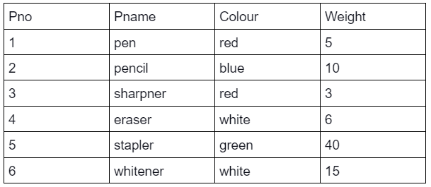

SUPPLIER

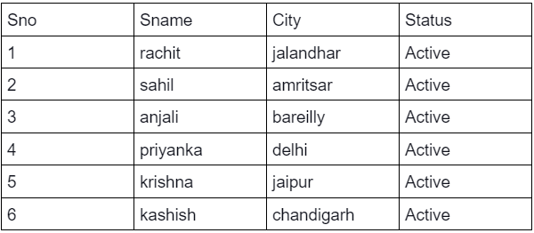

SP

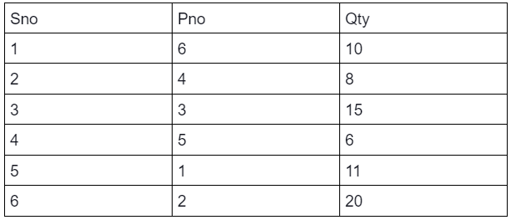

BUYER

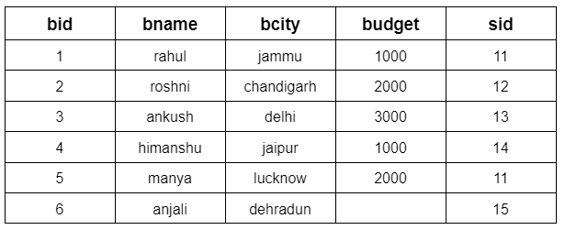

SELLER

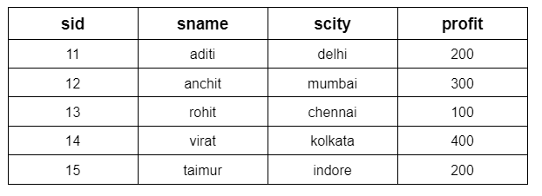

PRODUCT

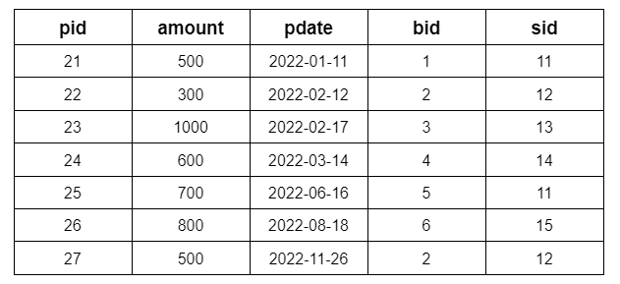

Q61: Enlist all the employees ID's, names along with the Project allocated to them.

SELECT E.EMPID, E.EMPFNAME, E.EMPLNAME, P.PROJECTID, P.PROJECTNAME

FROM EMPLOYEE E

INNER JOIN PROJECT P

ON E.EMPID = P.EMPID;

+-------+-----------+----------+-----------+-------------+

| EMPID | EMPFNAME | EMPLNAME | PROJECTID | PROJECTNAME |

+-------+-----------+----------+-----------+-------------+

| 1 | Riya | Khanna | 100 | pro_1 |

| 2 | Sahil | Kumar | 200 | pro_2 |

| 3 | Vishwas | Aanand | 300 | pro_3 |

| 3 | Vishwas | Aanand | 400 | pro_4 |

| 5 | Priyanshu | Gupta | 500 | pro_5 |

+-------+-----------+----------+-----------+-------------+

Q62: Fetch out all the employee ID’s and their contact detail who have been working from Delhi or have clients in Kolkata.

SELECT E.EMPID, E.EMAILID, E.PHONENO, C.CLIENTFNAME, C.CLIENTLNAME

FROM EMPLOYEE E

INNER JOIN CLIENT_D C

ON E.EMPID = C.EMPID

WHERE E.CITY IN ('DELHI', 'KOLKATA');

+-------+-----------------+-----------+-------------+-------------+

| EMPID | EMAILID | PHONENO | CLIENTFNAME | CLIENTLNAME |

+-------+-----------------+-----------+-------------+-------------+

| 3 | vishwas@abc.com | 987658871 | Steve | Rogers |

| 3 | vishwas@abc.com | 987658871 | Dustin | Poirier |

| 1 | riya@abc.com | 987655443 | Avinash | Jain |

+-------+-----------------+-----------+-------------+-------------+

Q63: List out all the project names with corresponding client’s email id, for all the projects that were allocated after April 2021 and order them in descending order of the age of clients.

SELECT P.PROJECTNAME, C.CLIENTEMAILID

FROM PROJECT P

INNER JOIN CLIENT_D C

ON P.CLIENTID = C.CLIENTID

WHERE P.PROJECTSTARTDATE >= '2021-05-01'

ORDER BY C.AGE DESC;

+-------------+-----------------+

| PROJECTNAME | CLIENTEMAILID |

+-------------+-----------------+

| pro_7 | dustin@ufc.com |

| pro_8 | avinash@leg.com |

| pro_5 | sushant@tek.com |

+-------------+-----------------+

Q64: Write an SQL query to inner join all the three table(Supplier, SP and Product) and print all the elements of the table. The tables should be joined in the same order as stated above.

SELECT S.SNO, S.SNAME, S.CITY, S.STATUS, SP.SNO, SP.PNO, SP.QTY, P.PNO, P.PNAME, P.COLOUR, P.WEIGHT

FROM SUPPLIER S

INNER JOIN SP

INNER JOIN PRODUCT P

ON S.SNO = SP.SNO AND P.PNO = SP.PNO;

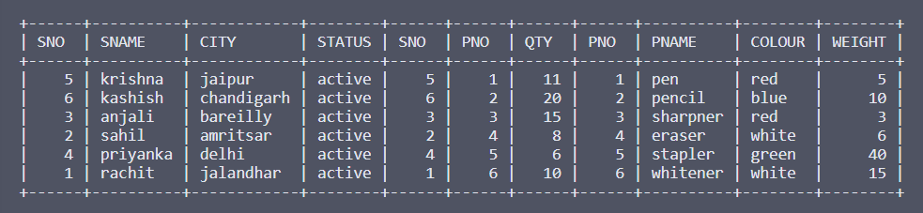

Q65: Write a SQL query to find the name, colour and quantity of the product supplied by sahil. The tables (Supplier, SP and Product) should be joined in the same order as stated above.

SELECT P.PNAME, P.COLOUR, SP.QTY

FROM SUPPLIER S

INNER JOIN SP

INNER JOIN PRODUCT P

ON S.SNO = SP.SNO AND P.PNO = SP.PNO

WHERE S.SNAME IN ('SAHIL');

+--------+--------+------+

| PNAME | COLOUR | QTY |

+--------+--------+------+

| eraser | white | 8 |

+--------+--------+------+

Q66: Write an SQL query to find the number of products supplied by each colour.

SELECT P.COLOUR, COUNT(SP.QTY) AS NOP

FROM PRODUCT P

INNER JOIN SP

ON P.PNO = SP.PNO

GROUP BY P.COLOUR;

+--------+-----+

| COLOUR | NOP |

+--------+-----+

| white | 2 |

| red | 2 |

| green | 1 |

| blue | 1 |

+--------+-----+

Q67: Write a SQL query to find the max quantity (Qty) supplied by each status. The tables (Supplier, SP and Product) should be joined in the same order as stated in bracket.

SELECT S.STATUS, MAX(SP.QTY) AS M

FROM SUPPLIER S

INNER JOIN SP

ON S.SNO = SP.SNO

GROUP BY S.STATUS;

+----------+------+

| STATUS | M |

+----------+------+

| active | 20 |

| inactive | 8 |

+----------+------+

Q68: Write a SQL query to display the supplier name, product name and their active status in order of the quantity supplied. The tables (Supplier, SP and Product) should be joined in the same order as stated above.

SELECT S.SNAME, P.PNAME, S.STATUS

FROM SUPPLIER S

INNER JOIN SP

INNER JOIN PRODUCT P

ON S.SNO = SP.SNO AND P.PNO = SP.PNO

ORDER BY SP.QTY;

+----------+----------+--------+

| SNAME | PNAME | STATUS |

+----------+----------+--------+

| priyanka | stapler | active |

| sahil | eraser | active |

| rachit | whitener | active |

| krishna | pen | active |

| anjali | sharpner | active |

| kashish | pencil | active |

+----------+----------+--------+

Q69: Fetch out each project allocated to which employee.

SELECT E.EMPFNAME, E.EMPLNAME, P.PROJECTID, P.PROJECTNAME

FROM EMPLOYEE E

LEFT JOIN PROJECT P

ON E.EMPID = P.EMPID;

+-----------+----------+-----------+-------------+

| EMPFNAME | EMPLNAME | PROJECTID | PROJECTNAME |

+-----------+----------+-----------+-------------+

| Riya | Khanna | 100 | pro_1 |

| Sahil | Kumar | 200 | pro_2 |

| Vishwas | Aanand | 400 | pro_4 |

| Vishwas | Aanand | 300 | pro_3 |

| Harleen | Kaur | NULL | NULL |

| Priyanshu | Gupta | 500 | pro_5 |

+-----------+----------+-----------+-------------+

Q70: Write a SQL statement to make a report with buyer name, buyer city, product ID, purchased date, and amount in ascending order of the purchased date to find that either any of the existing customers have purchased any product or not.

SELECT B.BNAME, B.BCITY, P.PID, P.PDATE, P.AMOUNT

FROM BUYER B

LEFT JOIN PRODUCT P

ON B.BID = P.BID

ORDER BY P.PDATE;

+----------+------------+------+------------+--------+

| BNAME | BCITY | PID | PDATE | AMOUNT |

+----------+------------+------+------------+--------+

| rahul | jammu | 21 | 2022-01-11 | 500 |

| roshni | chandigarh | 22 | 2022-02-12 | 300 |

| ankush | delhi | 23 | 2022-02-17 | 1000 |

| himanshu | jaipur | 24 | 2022-03-14 | 600 |

| manya | lucknow | 25 | 2022-06-16 | 700 |

| anjali | dehradun | 26 | 2022-08-18 | 800 |

| roshni | chandigarh | 27 | 2022-11-26 | 500 |

+----------+------------+------+------------+--------+

Q71: Write a SQL query to find those buyers whose budget is less than 3000. Display the Buyer name, city, budget and Seller's name & city. The result should be in ascending order of buyers ID.

SELECT B.BNAME, B.BCITY, B.BUDGET, S.SNAME, S.SCITY

FROM BUYER B

LEFT JOIN SELLER S

ON B.SID = S.SID

WHERE B.BUDGET < 3000;

+----------+------------+--------+--------+---------+

| BNAME | BCITY | BUDGET | SNAME | SCITY |

+----------+------------+--------+--------+---------+

| rahul | jammu | 1000 | aditi | delhi |

| roshni | chandigarh | 2000 | anchit | mumbai |

| himanshu | jaipur | 1000 | virat | kolkata |

| manya | lucknow | 2000 | aditi | delhi |

+----------+------------+--------+--------+---------+

Q72: Write a SQL query to make a report, with buyer name, buyer city, product number, purchased date, amount, seller name and profit to find that either any of the existing buyer have purchased any product or not, by their seller.

SELECT B.BNAME, B.BCITY, P.PID, P.PDATE, P.AMOUNT, S.SNAME, S.PROFIT

FROM BUYER B

LEFT JOIN PRODUCT P ON B.BID = P.BID

LEFT JOIN SELLER S ON B.SID = S.SID;

+----------+------------+------+------------+--------+--------+--------+

| BNAME | BCITY | PID | PDATE | AMOUNT | SNAME | PROFIT |

+----------+------------+------+------------+--------+--------+--------+

| rahul | jammu | 21 | 2022-01-11 | 500 | aditi | 200 |

| roshni | chandigarh | 27 | 2022-11-26 | 500 | anchit | 300 |

| roshni | chandigarh | 22 | 2022-02-12 | 300 | anchit | 300 |

| ankush | delhi | 23 | 2022-02-17 | 1000 | rohit | 100 |

| himanshu | jaipur | 24 | 2022-03-14 | 600 | virat | 400 |

| manya | lucknow | 25 | 2022-06-16 | 700 | aditi | 200 |

| anjali | dehradun | 26 | 2022-08-18 | 800 | taimur | 200 |

+----------+------------+------+------------+--------+--------+--------+

Q73: List out all the projects along with the employee's name and their respective allocated email ID.

SELECT P.PROJECTID, P.PROJECTNAME, E.EMPFNAME, E.EMPLNAME, E.EMAILID

FROM PROJECT P

LEFT JOIN EMPLOYEE E

ON P.EMPID = E.EMPID;

SELECT P.PROJECTID, P.PROJECTNAME, E.EMPFNAME, E.EMPLNAME, E.EMAILID

FROM EMPLOYEE E

RIGHT JOIN PROJECT P

ON P.EMPID = E.EMPID;

+-----------+-------------+-----------+----------+-------------------+

| PROJECTID | PROJECTNAME | EMPFNAME | EMPLNAME | EMAILID |

+-----------+-------------+-----------+----------+-------------------+

| 100 | pro_1 | Riya | Khanna | riya@abc.com |

| 200 | pro_2 | Sahil | Kumar | sahil@abc.com |

| 300 | pro_3 | Vishwas | Aanand | vishwas@abc.com |

| 400 | pro_4 | Vishwas | Aanand | vishwas@abc.com |

| 500 | pro_5 | Priyanshu | Gupta | priyanshu@abc.com |

| 600 | pro_6 | NULL | NULL | NULL |

| 700 | pro_7 | NULL | NULL | NULL |

| 800 | pro_8 | NULL | NULL | NULL |

+-----------+-------------+-----------+----------+-------------------+

Q74: List out all the client details email address, whose age is between 25 to 35, along with the projects assigned to them in ascending order of their age and project ID. Also, use c for client_d and p for project, as alias name of tables.

SELECT C.CLIENTID, C.CLIENTFNAME, C.CLIENTLNAME, C.CLIENTEMAILID, P.PROJECTID, P.PROJECTNAME

FROM PROJECT P

RIGHT JOIN CLIENT_D C

ON C.CLIENTID = P.CLIENTID

WHERE C.AGE BETWEEN 25 AND 35

ORDER BY C.AGE, P.PROJECTID;

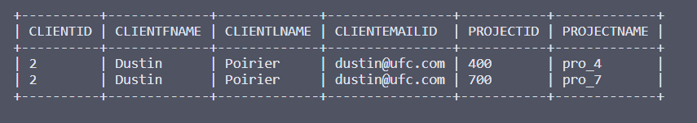

Q75: Write a SQL statement to make a list in ascending order for the sellers, display the buyer's name, city, budget, and seller's name & city.

SELECT BUYER.BNAME, BUYER.BCITY, BUYER.BUDGET, SELLER.SNAME, SELLER.SCITY

FROM BUYER

RIGHT JOIN SELLER ON BUYER.SID = SELLER.SID

ORDER BY SELLER.SID;

+----------+------------+--------+--------+---------+

| BNAME | BCITY | BUDGET | SNAME | SCITY |

+----------+------------+--------+--------+---------+

| manya | lucknow | 2000 | aditi | delhi |

| rahul | jammu | 1000 | aditi | delhi |

| roshni | chandigarh | 2000 | anchit | mumbai |

| ankush | delhi | 3000 | rohit | chennai |

| himanshu | jaipur | 1000 | virat | kolkata |

| anjali | dehradun | NULL | taimur | indore |

+----------+------------+--------+--------+---------+

Q76: Write a SQL query to list all sellers along with the buyer's name, buyer city, budget, product ID, purchased date, and purchased amount to find that either any of the existing sellers have sold any product or not.

SELECT BUYER.BNAME, BUYER.BCITY, BUYER.BUDGET, SELLER.SNAME, PRODUCT.PID, PRODUCT.PDATE, PRODUCT.AMOUNT

FROM BUYER

RIGHT JOIN SELLER ON BUYER.SID = SELLER.SID

RIGHT JOIN PRODUCT ON BUYER.BID = PRODUCT.BID;

+----------+------------+--------+--------+------+------------+--------+

| BNAME | BCITY | BUDGET | SNAME | PID | PDATE | AMOUNT |

+----------+------------+--------+--------+------+------------+--------+

| rahul | jammu | 1000 | aditi | 21 | 2022-01-11 | 500 |

| roshni | chandigarh | 2000 | anchit | 22 | 2022-02-12 | 300 |

| ankush | delhi | 3000 | rohit | 23 | 2022-02-17 | 1000 |

| himanshu | jaipur | 1000 | virat | 24 | 2022-03-14 | 600 |

| manya | lucknow | 2000 | aditi | 25 | 2022-06-16 | 700 |

| anjali | dehradun | NULL | taimur | 26 | 2022-08-18 | 800 |

| roshni | chandigarh | 2000 | anchit | 27 | 2022-11-26 | 500 |

+----------+------------+--------+--------+------+------------+--------+

Q77: List out all the combinations possible for the employee’s name and projects that can exist(NULL included).

SELECT EMPLOYEE.EMPFNAME, EMPLOYEE.EMPLNAME, PROJECT.PROJECTID

FROM EMPLOYEE

CROSS JOIN PROJECT;

+-----------+----------+-----------+

| EMPFNAME | EMPLNAME | PROJECTID |

+-----------+----------+-----------+

| Priyanshu | Gupta | 100 |

| Harleen | Kaur | 100 |

| Vishwas | Aanand | 100 |

| Sahil | Kumar | 100 |

| Riya | Khanna | 100 |

| Priyanshu | Gupta | 200 |

| Harleen | Kaur | 200 |

| Vishwas | Aanand | 200 |

| Sahil | Kumar | 200 |

| Riya | Khanna | 200 |

| Priyanshu | Gupta | 300 |

| Harleen | Kaur | 300 |

| Vishwas | Aanand | 300 |

| Sahil | Kumar | 300 |

| Riya | Khanna | 300 |

| Priyanshu | Gupta | 400 |

| Harleen | Kaur | 400 |

| Vishwas | Aanand | 400 |

| Sahil | Kumar | 400 |

| Riya | Khanna | 400 |

| Priyanshu | Gupta | 500 |

| Harleen | Kaur | 500 |

| Vishwas | Aanand | 500 |

| Sahil | Kumar | 500 |

| Riya | Khanna | 500 |

| Priyanshu | Gupta | 600 |

| Harleen | Kaur | 600 |

| Vishwas | Aanand | 600 |

| Sahil | Kumar | 600 |

| Riya | Khanna | 600 |

| Priyanshu | Gupta | 700 |

| Harleen | Kaur | 700 |

| Vishwas | Aanand | 700 |

| Sahil | Kumar | 700 |

| Riya | Khanna | 700 |

| Priyanshu | Gupta | 800 |

| Harleen | Kaur | 800 |

| Vishwas | Aanand | 800 |

| Sahil | Kumar | 800 |

| Riya | Khanna | 800 |

+-----------+----------+-----------+

Q78: Write a SQL query to make a list with the buyer’s name, buyer’s city, product id, purchased date and the amount for only those buyers in the table who must have a budget.

SELECT BUYER.BNAME, BUYER.BCITY, PRODUCT.PID, PRODUCT.PDATE, PRODUCT.AMOUNT

FROM BUYER

LEFT JOIN PRODUCT

ON BUYER.BID = PRODUCT.BID

WHERE BUYER.BUDGET IS NOT NULL

UNION

SELECT BUYER.BNAME, BUYER.BCITY, PRODUCT.PID, PRODUCT.PDATE, PRODUCT.AMOUNT

FROM BUYER

RIGHT JOIN PRODUCT

ON BUYER.BID = PRODUCT.BID

WHERE BUYER.BUDGET IS NOT NULL;

+----------+------------+------+------------+--------+

| BNAME | BCITY | PID | PDATE | AMOUNT |

+----------+------------+------+------------+--------+

| rahul | jammu | 21 | 2022-01-11 | 500 |

| roshni | chandigarh | 27 | 2022-11-26 | 500 |

| roshni | chandigarh | 22 | 2022-02-12 | 300 |

| ankush | delhi | 23 | 2022-02-17 | 1000 |

| himanshu | jaipur | 24 | 2022-03-14 | 600 |

| manya | lucknow | 25 | 2022-06-16 | 700 |

+----------+------------+------+------------+--------+

Q79: Formulate a MySQL query to list out all the projects(id, name) and employee's names (first, last) along with their respective Email id’s irrespective of the fact if that project is assigned or not and whether an employee is assigned any project or none.

SELECT PROJECT.PROJECTID, PROJECT.PROJECTNAME, EMPLOYEE.EMPFNAME, EMPLOYEE.EMPLNAME, EMPLOYEE.EMAILID

FROM PROJECT

LEFT JOIN EMPLOYEE

ON PROJECT.EMPID = EMPLOYEE.EMPID

UNION

SELECT PROJECT.PROJECTID, PROJECT.PROJECTNAME, EMPLOYEE.EMPFNAME, EMPLOYEE.EMPLNAME, EMPLOYEE.EMAILID

FROM PROJECT

RIGHT JOIN EMPLOYEE

ON PROJECT.EMPID = EMPLOYEE.EMPID;

+-----------+-------------+-----------+----------+-------------------+

| PROJECTID | PROJECTNAME | EMPFNAME | EMPLNAME | EMAILID |

+-----------+-------------+-----------+----------+-------------------+

| 100 | pro_1 | Riya | Khanna | riya@abc.com |

| 200 | pro_2 | Sahil | Kumar | sahil@abc.com |

| 300 | pro_3 | Vishwas | Aanand | vishwas@abc.com |

| 400 | pro_4 | Vishwas | Aanand | vishwas@abc.com |

| 500 | pro_5 | Priyanshu | Gupta | priyanshu@abc.com |

| 600 | pro_6 | NULL | NULL | NULL |

| 700 | pro_7 | NULL | NULL | NULL |

| 800 | pro_8 | NULL | NULL | NULL |

| NULL | NULL | Harleen | Kaur | harleen@abc.com |

+-----------+-------------+-----------+----------+-------------------+